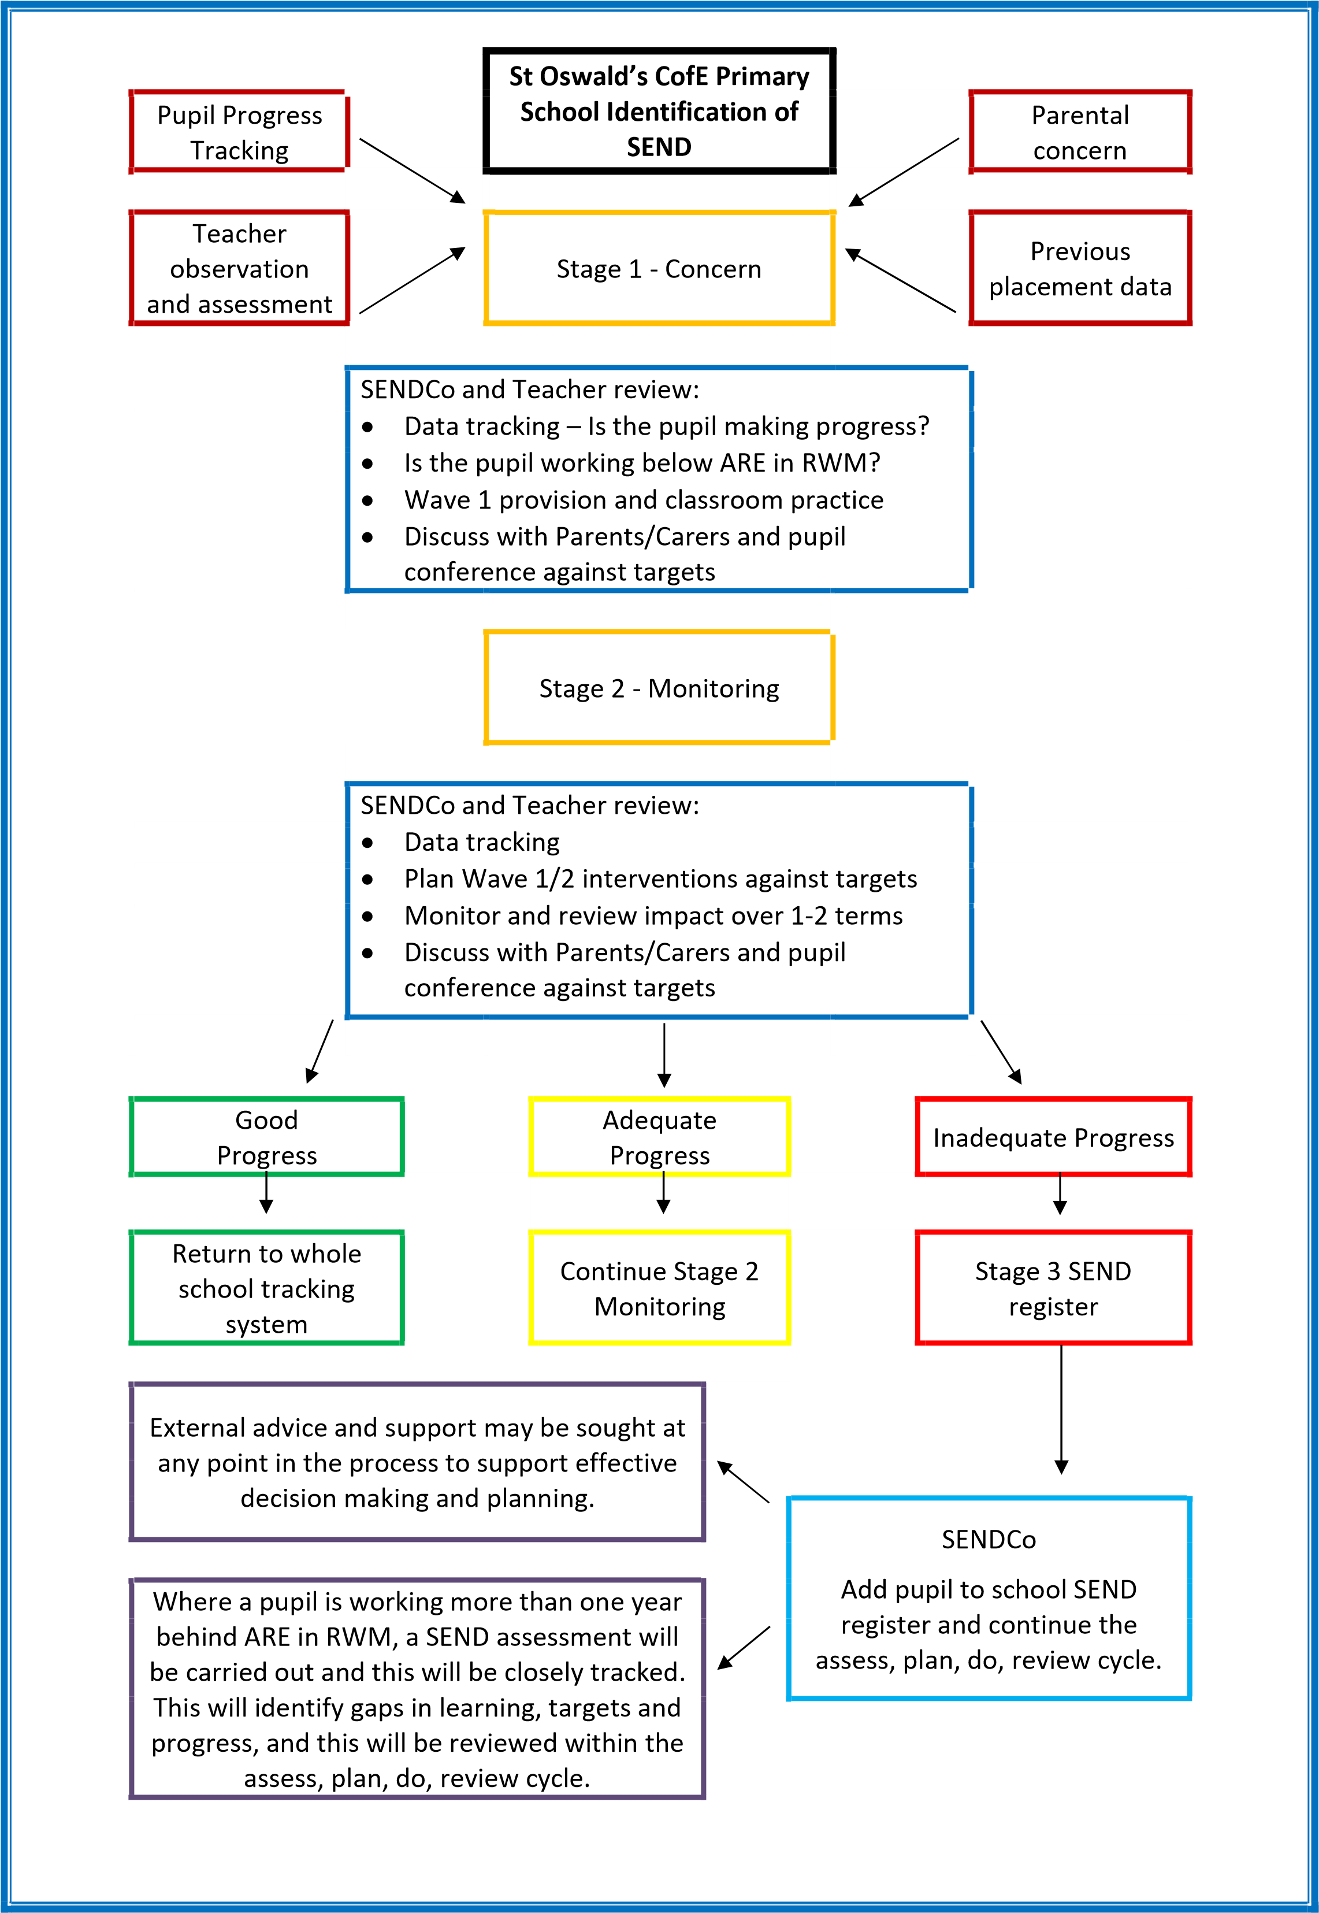
SENCo and Teacher Review:
- Data - any improvements?
- Set targets through Class-Based or School Support
- Monitor and review impact
- Teacher to keep Parents/Carers informed

SENCo and Teacher Review:
- Data tracking- Is the pupil making progress? Are they working below ARE in RWM?
- Is the pupil struggling socially, emotionally or struggling to follow the Belle Vue Way?
- SNAP assessments to be completed to help identify need and pupil voice sought
- Teacher/SENCo to discuss concerns with Parent/Carers
In consultation with the SENCo, parents and teaching staff, pupils may be added to the SEND register as part of the Graduated Approach; Assess-Plan-Do-Review (APDR).
Support Plans will be created with targets and reviewed at least three times a year and parents invited to discuss progress towards these targets with the class teacher.
Belle Vue Primary School
Identification of SEND
Refer pupil to external agency

Continue to monitor
Interventions will be considered for children who are working more than a year behind ARE. These will be closely monitored to ensure the attainment gaps are closing. These will be in addition to High Quality teaching.

